**Project Design Phase-II**

**Technology Stack (Architecture & Stack)**

|  |  |
| --- | --- |
| Date | 7 November 2022 |
| Team ID | PNT2022TMID13490 |
| Project Name | Gas Leakage monitoring & Alerting system |
| Maximum marks | 4 Marks |

**Architecture:**



**Technical Architecture:**

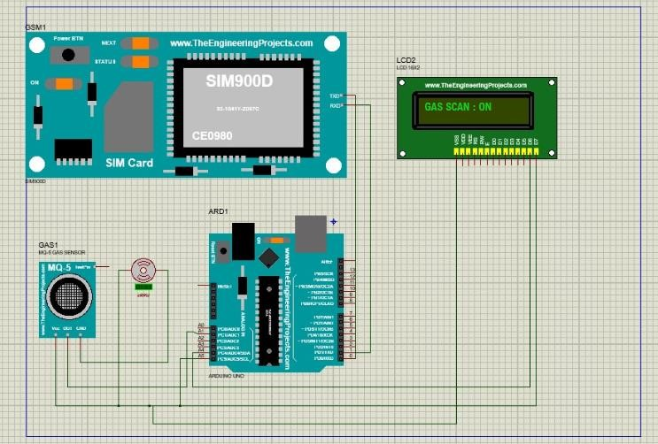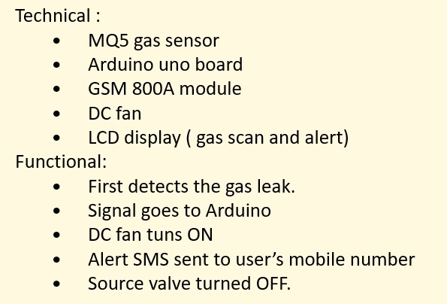

**DEVELOPMENT OF TASK ANALYSIS:**

**Hardware Requirements**

1. Arduino UNO Microcontroller
2. Green LED 1, Red LED 3
3. 9V Power supply (230V TO 9V STEPDOWN TRANSFORMER)
4. MQ6 Gas sensor
5. GSM 800 Module
6. GSM Sim
7. Connecting wires
8. Project base

**Software Requirements**

1. Arduino IDE
2. Language C++

**WORKING:**

**Step 1**: A signal from the microcontroller will go to the display and show gas leakage message there.

**Step 2**: Simultaneously automatically turns on the DC fan to ventilate the leaked gas, and the source solenoid valve will be turns off

**Step 3**: Signal from microcontroller activates the GSM module and sends an alert SMS “ALERT GAS LEAKING” to the user’s mobile number.